Python & Bash Assignment
Github:- https://github.com/ShravanSM/Devops
1. Grade Checker
Take a score as input and print the grade based on the following:
- 90+ : “A”
- 80–89 : “B”
- 70–79 : “C”
- 60–69 : “D”
- Below 60 : “F”
Code:
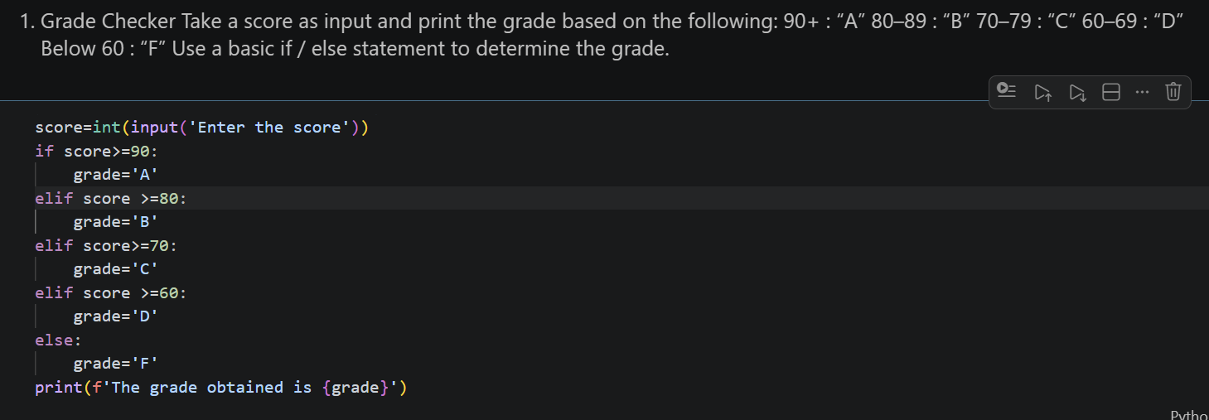
2. Student Grades
Create a dictionary where the keys are student names and the values are their grades. Allow the user to:
- Add a new student and grade.
- Update an existing student's grade.
- Print all student grades.
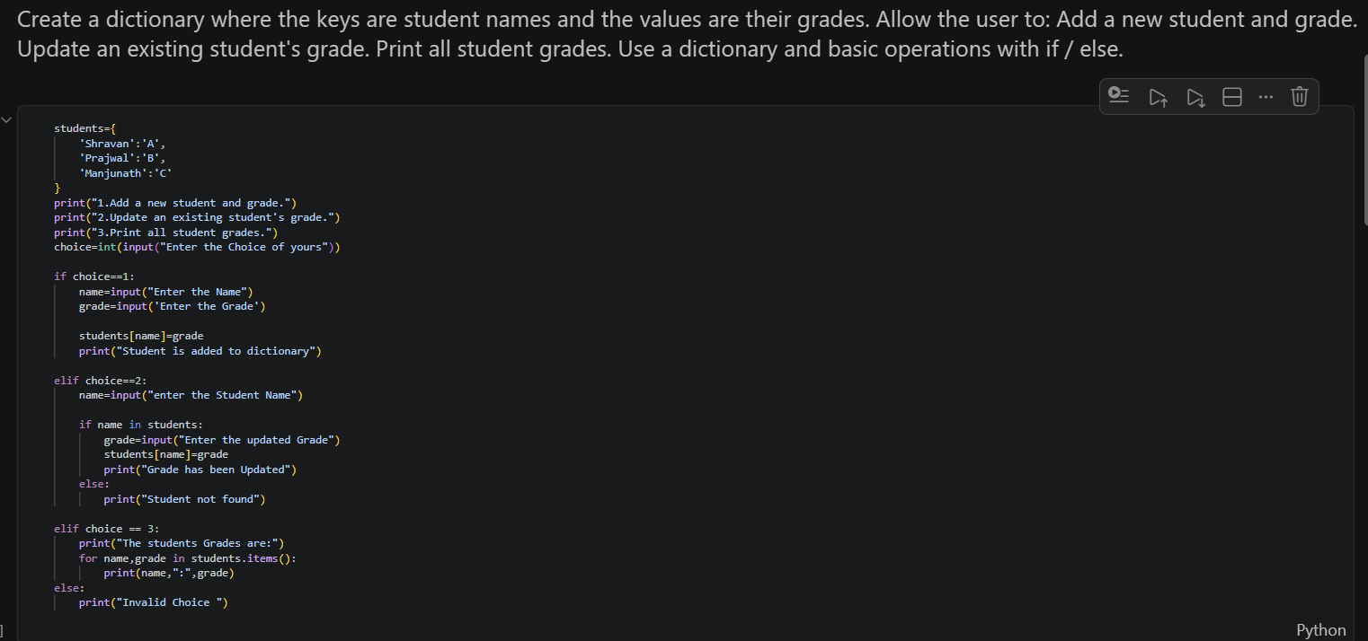
- Use a dictionary and basic operations with if / else.
3. Write to a File
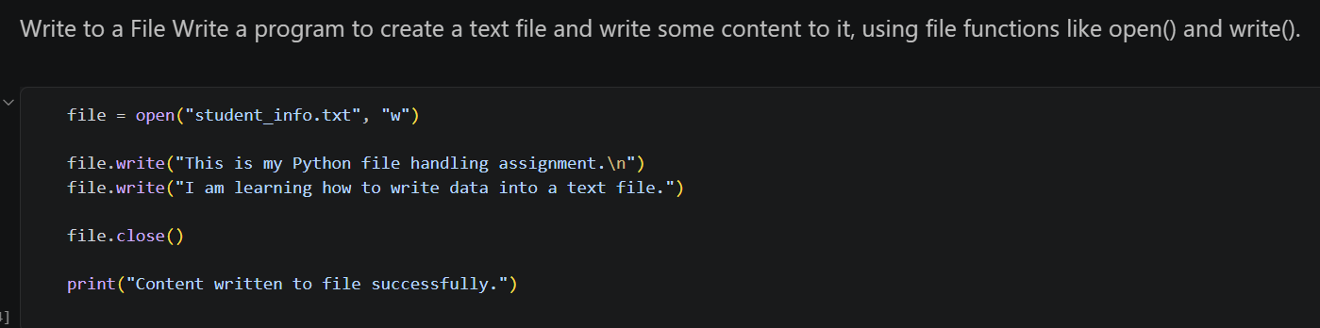
- Write a program to create a text file and write some content to it, using file functions like open() and write().

4. Read from a File
- Open the file in read mode and use file.read() to read and display its content.
